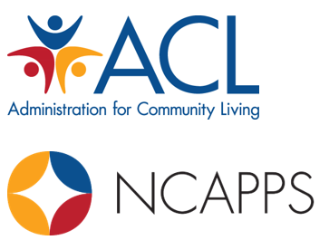



Office of Healthcare Information and Counseling

Demographic Data Visualization Toolkit

September 2024

By Saska Rajcevic and Jewel Constance



# Table of Contents

Introduction 3

Pulling Quantitative Demographic Data 4

Visualizing the Data 6

Incorporating Qualitative Data 6

Understanding the Data 6

Trends 6

Representativeness 7

Barriers 7

Strategies for Applying the Principles of Cultural Humility to Data Analysis 7

Action Planning 8

Conclusion 10

Template: At-A Glance Demographic Data 11

Appendix A. SIRS and STARS Data and Report Resources 13

About NCAPPS 14

Recommended Citation 14

Acknowledgments 14

**NCAPPS is supported by contract number HHSP233201500119I/HHSP23337002T from the U.S. Administration for Community Living, Department of Health and Human Services, Washington, D.C. 20201**

# Introduction

Cultural humility is an active, self-reflective, lifelong practice involving:

1. Continuous exploration of cultural identities and beliefs, and an awareness of one’s own biases
2. Treating others with respect, openness, and empathy
3. Reducing power imbalances within relationships and communities[1]

Practicing cultural humility has been found to result in better health and life outcomes for people as it breaks down power dynamics and reduces disparities.[2] Team members from the Senior Medicare Patrol (SMP), State Health Insurance Assistance Program (SHIP) and Medicaid Improvements for Patients and Providers Act (MIPPA) provide information on health insurance options to people across the country who hold various cultural identities. SMP, SHIP, and MIPPA team members also serve as a point of connection to other supportive services to holistically support older adults and people with disabilities. As a result, team members regularly collect demographic data to better understand the people they support. This includes gathering information about age, gender identity, sexual orientation, race, primary language, and income.

By reviewing demographic data on a regular basis, SMP, SHIP, and MIPPA team members can identify which populations they are and aren’t reaching effectively, outline areas for improvement, and brainstorm innovative approaches to conducting outreach.

This resource provides an overview of how team members can use existing demographic data to better understand their communities and in turn, provide more person-centered support to beneficiaries. This toolkit was created through work conducted by the [National Center on Advancing Person-Centered Practices and Systems (NCAPPS)](https://ncapps.acl.gov/home.html) and funded by the Administration for Community Living (ACL) to strengthen cultural humility among SMP, SHIP, and MIPPA team members. NCAPPS would like to acknowledge the contributions of team members within the Cultural Humility workgroup who helped guide the development of this resource.

# Pulling Quantitative Demographic Data

The [SHIP Tracking and Reporting System (STARS)](https://stars.acl.gov/) and the [SMP Information and Reporting System (SIRS)](https://sirs.acl.gov/) are the two nationwide web-based data systems that facilitate the reporting of SHIP, SMP, and MIPPA grantee activities to the federal government. While a handful or reports and searches contain demographic information, the simplest way to review demographic data is to locate the STARS and SIRS Summary Reports in the Configuration tab (hover over Pages and then Share Pages).

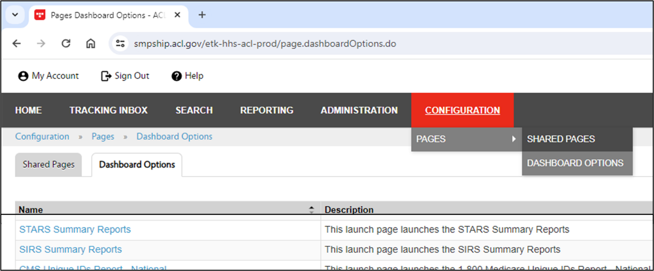

There are a few considerations to keep in mind when pulling the STARS and SIRS summary reports:

* The scope of report timing is limited. As a result, making a multiyear comparison as advised requires downloading and collating Summary Reports.
  + STARS has a six-month limit.
  + SIRS has a one-year limit.
* Varied permissions offer state, partner organization, and team member level reports.

Convert the Summary Report data in Excel from “text” to “number”. Highlight the cells to convert, click the yield sign dropdown, and select ‘convert to number’. Repeat for all sections of demographic data in the Summary Report and save the changes. 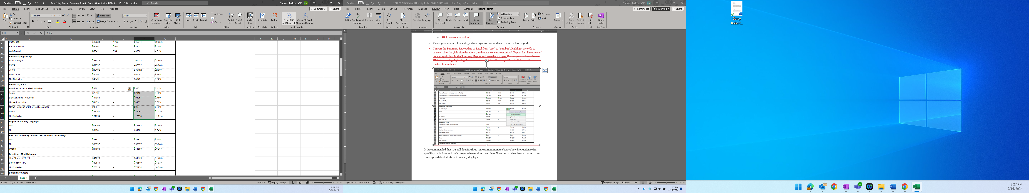

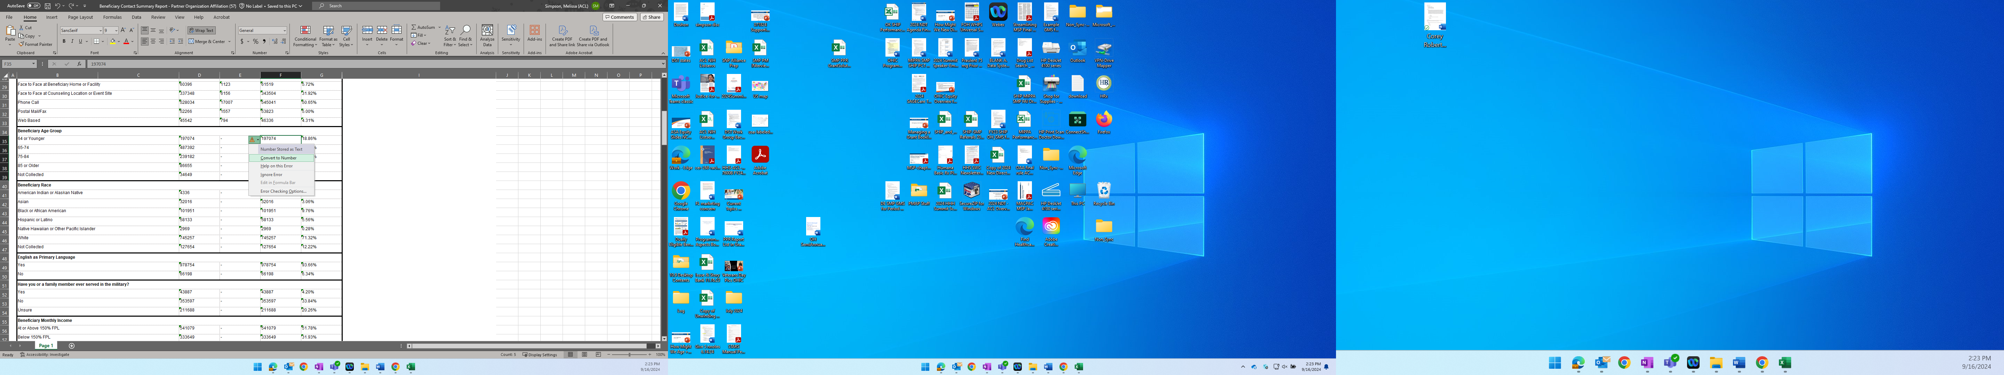

It is recommended that you pull data for three years at minimum to observe how interactions with specific populations and their program have shifted over time. Once the data has been exported to an Excel spreadsheet, it’s time to visually display it.

# Visualizing the Data

# The image shows eight types of chart icons and labeled 'Charts' at the bottom middle. The charts include Stacked bar chart, Line chart, Area chart, Pie chart, scatter plot, Bar chart.

Using graphs and charts to organize the demographic data can help you to quickly observe trends over time and disaggregate data. To create charts within the Excel spreadsheet, select the data for which you want to create a chart. Click “insert,” navigate to the “Charts” section, and click the column charts icon in the upper left-hand corner to select a chart. It is recommended that you use a clustered column chart (located under the 2-D) column. Create charts for the five primary sets of demographic data: age, gender identity, race, and income. Once complete, copy the charts into a Word document. We encourage using the template in this resource for display.

# Incorporating Qualitative Data

Beyond the demographic data collected in SIRS and STARS, you and your team may have also gathered qualitative data through interactions with beneficiaries (textual, non-numerical data) in the form of stories, experiences, anecdotes, etc. that can help inform outreach efforts to underserved communities. It can be helpful to do a quick “audit” of other data that you collect. Qualitative data can be paired with the quantitative data from SIRS and STARS to tell a story, provide context for the data, and determine future goals.

# Understanding the Data

## Trends

Once you’ve created the charts, review how data has changed over time and pay particularly close attention to any significant increases or decreases among the demographic data. Consider as well if there are any outreach efforts, initiatives, or local/global life events that may be correlated with data shifts. For example, you may observe an increase in your outreach to Hispanic or Latino communities because you’ve recently partnered with a local community center to provide in-person informational events in Spanish. Alternatively, you may experience a decrease if there has been a string of violent attacks on Latino people in your community that may impact whether they feel safe attending those informational sessions. In this instance, you would then need to adjust your existing outreach efforts to be more culturally responsive to the population you are seeking to connect with.

Additionally, it’s crucial to highlight when percentages have remained low and stagnant over the years for underrepresented populations. Little to no fluctuation in these data points can reveal that existing outreach efforts are not sufficient. Outreach may not be effective for several reasons such as lack of trust, frequency, or accessibility. It may also be that at one time, a specific outreach strategy for a population was highly effective but is no longer having much of an impact. Taking a step back to evaluate whether to continue certain initiatives or shift gears can influence your ability to better connect with underrepresented populations.

## Representativeness

It’s important to also consider how representative the data is in relation to the overall population of your state or local community. For example, if you know your state has an Asian population of around 5% but your data shows that out of the total population of people you’ve interacted with over the past three years, only 1% are Asian, you will want to consider why that is and if there are things you can do to better connect with that population. You can visit the [United States Census](https://data.census.gov/profile) to look up your state or county population level data using the various data profiles available. Additionally, you may want to review the population of people receiving Medicare in your state or community in comparison to people not receiving Medicare. You can use the [Mapping Medicare Disparities by Population](https://data.cms.gov/tools/mapping-medicare-disparities-by-population) tool by the Centers for Medicare and Medicaid Services for this.

## Barriers

In reviewing your data, outlining what the barriers are to meaningful outreach for specific populations can also help you identify action steps.

## Strategies for Applying the Principles of Cultural Humility to Data Analysis

Below is a summary of how to apply the principles of cultural humility to your data analysis. Doing so can help you can gain a deeper understanding of the diverse communities you serve and respond to their needs with effective outreach strategies. Using data thoughtfully is a powerful tool to ensure your engagement efforts are truly inclusive and impactful.

* **Disaggregate the data**: Break down your data by various demographic factors like race, ethnicity, language, and socioeconomic status. This helps you identify potential disparities in access to services, health outcomes, or outreach efforts.
* **Look for patterns and trends:** Analyze the data to see if there are any recurring patterns or trends related to specific cultural groups. This can help you tailor your outreach strategies to better address their unique needs and preferences.
* **Partner with community members:** Collaborate with individuals from the communities you serve to interpret the data and gain deeper insights. This ensures your understanding is grounded in lived experiences and avoids misinterpretations.
* **Use data to inform culturally relevant outreach:** Based on your findings, develop targeted outreach materials and communication strategies that resonate with specific cultural groups. This could involve using culturally appropriate language, visuals, and channels of communication.
* **Continuously evaluate and adapt:** Regularly monitor the effectiveness of your outreach efforts and use data to inform adjustments. Be open to feedback from your community and adapt your strategies as needed.

# Action Planning

Now that you've extracted data and gained insights into the diverse communities you serve, it's time to translate that knowledge into action. This section will guide you through creating a clear and actionable plan to leverage your data for culturally responsive outreach and engagement.

## SMARTIE Goals:

Start by setting SMARTIE goals for your cultural humility initiatives. SMARTIE stands for:

* **Specific:** Clearly define your goal and what you want to achieve.
* **Measurable:** Establish a way to track your progress and measure the impact of your actions.
* **Attainable:** Set realistic and achievable goals within your resources and timeframe.
* **Relevant:** Ensure your goals align with the needs of the communities you serve and your overall cultural humility objectives.
* **Time-bound:** Set a clear deadline for achieving your goals.
* **Inclusive:** Consider the diverse perspectives and needs of the communities you serve when setting your goals.
* **Equity-focused:** Aim to reduce disparities and promote equitable access to services and resources.

## PDSA Cycle:

The Plan-Do-Study-Act (PDSA) cycle[3] provides a structured framework for implementing your action plan and continuously improving your cultural humility efforts. Here's how it works:

* **Plan:** Develop a specific action based on your SMARTIE goals. This could involve developing culturally targeted outreach materials, partnering with community organizations, or implementing new training programs for staff.
* **Do:** Put your plan into action and implement the chosen strategy.
* **Study:** Monitor and evaluate the effectiveness of your actions. Analyze data, gather feedback from community members, and assess the impact of your efforts.
* **Act:** Based on your findings, adjust your plan as needed. This could involve refining your strategy, expanding your outreach efforts, or addressing any identified challenges.

## Example Use of the PDSA Cycle:

**Goal:** Increase the number of culturally targeted outreach events for the Pacific Islander community by 20% within the next six months.

## PDSA Cycle:

* **Plan:** Develop a series of culturally relevant workshops and events focused on health education and resource access for the Pacific Islander community. Partner with local Pacific Islander organizations to ensure authenticity and reach.
* **Do:** Implement the planned events, ensuring they are accessible and culturally appropriate.
* **Study:** Track attendance, gather feedback from participants, and analyze data on engagement.
* **Act:** Based on the results, refine future events to address identified needs and preferences.

## Strategies for Practicing Cultural Humility:

Below are some potential strategies you can use in your action plan to practice cultural humility:

* **Ongoing learning:** Continuously educate yourself and your team about diverse cultures, implicit biases, and best practices for culturally responsive communication. You can do this through dedicated trainings or even walking around your community to familiarize yourself with available resources and partners.
* **Self-reflection:** Regularly reflect on your own biases and assumptions and how they might influence your interactions with others. This can even mean building in “user experience” questions on surveys after interactions with beneficiaries and evaluating the results to identify potential areas for improvement with interpersonal communication.
* **Building relationships:** Cultivate meaningful partnerships with individuals and organizations from the communities you serve. You could work in collaboration with trusted and respected community members to host events and share informational materials.
* **Valuing diverse perspectives:** Actively listen to and learn from the lived experiences of people from different backgrounds.
* **Adapting your approach:** Be flexible and willing to adjust your outreach strategies based on the specific needs and preferences of different cultural groups.

# Conclusion

Cultural humility is a continuous journey. By setting clear goals, utilizing the PDSA cycle, and implementing ongoing strategies, you can leverage your data to make a significant impact and create more inclusive and equitable outreach efforts for all communities you serve. Write out your SMARTIE goals in the included template to showcase how the review of your existing demographic data will impact your future efforts. You can use your completed template to discuss outreach strategies with other team members and keep track of your goals. It is recommended that you review and update the template on an annual basis to actively evaluate how well you are connecting with underrepresented communities. This is a long-term process and commitment. You likely won’t see a significant increase in your percentages until a few years down the road but it’s important to start today.

*[insert organizational logo]*

# Template: At-A Glance Demographic Data

*for [insert program name], [insert range of years]*

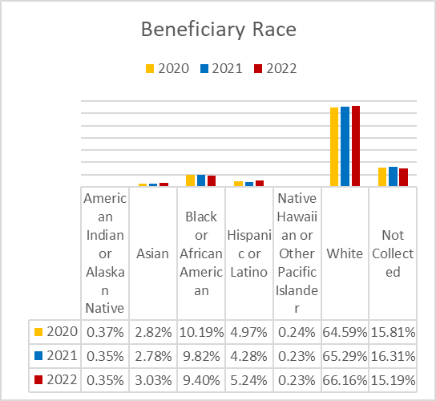 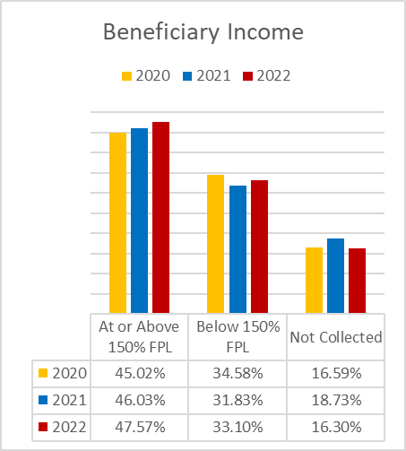

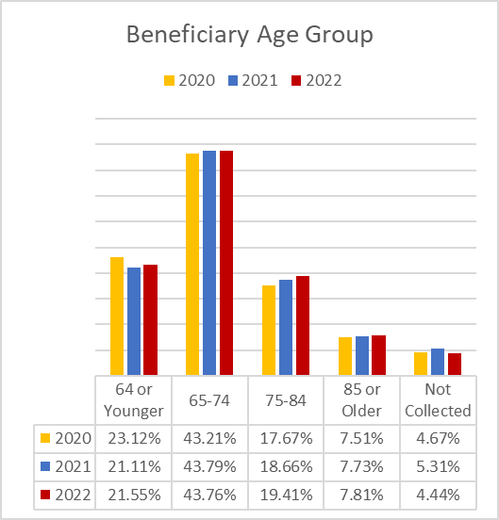 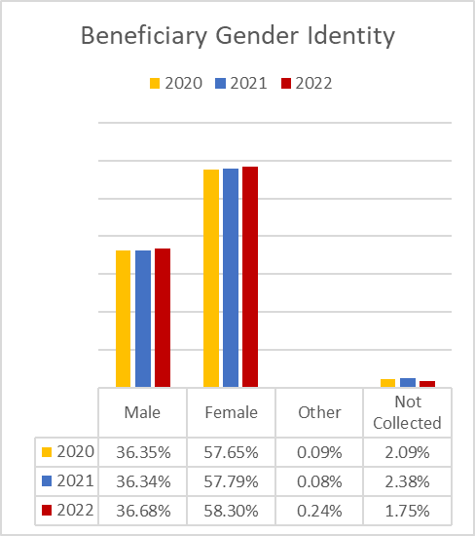

# Summary of Data

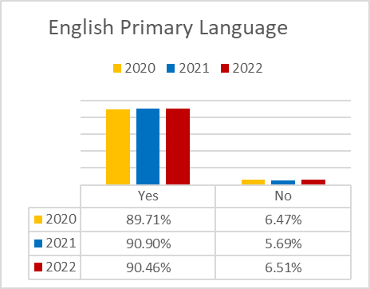

*[insert a brief summary of what the data trends show and highlight significant increases or decreases, i.e., “from 2020 to 2022, our contact with people who identify as a gender identity other than male, or female increased by o.16%”]*

# Lessons Learned

*[insert a summary of any innovative approaches or initiatives that may have supported certain data increases, along with any efforts that were not fruitful and may have led to declines in the data]*

# Representativeness of Data

*[visit the* [*United States Census website*](https://data.census.gov/profile) *to look up your state or county population level data using the various data profiles available; summarize whether your data shows that you may need to work on conducting outreach to specific populations i.e., the Census data shows that there is a 10% Asian population in your county but your SIRS data shows you have only been able to reach 1% of that population]*

# Goals

*[identify and insert SMARTIE goals based on data trends, i.e., “we will translate 50% of our outreach materials into Spanish by 10/01/24 to support increased efforts to engage with the Latino community”. Adjust numbers as needed.]*

**1.**

# Appendix A. SIRS and STARS Data and Report Resources

* **SIRS**
* **SIRS Reports Job Aide:** <https://smpresource.org/topics/sirs-reports-job-aid/>
* **OIG Report and Performance Measures Definitions and Guidance:** <https://smpresource.org/topics/smp-performance-measures-definitions-and-guidance/>
* **STARS**
  + **Chapters and Report Handouts**
* [Performance Measures Reports At-A-Glance References](https://portal.shiptacenter.org/Portal/Resource/Resource-Detail.aspx?ResourceGUID=4C6A1940-9EA8-41E3-A067-4554BDDC06AC) - job aids explaining the source of data for SHIP and MIPPA Performance Measures (PMs)
* [User Roles At-A-Glance Reference](https://portal.shiptacenter.org/Portal/Resource/Resource-Detail.aspx?ResourceGUID=38CD2CF1-8E13-4A28-86AA-63FA3274BF1C) - two-page table for determining who can access reports
* STARS Manual Chapter 6 Searches
* STARS Manual Chapter 8 Reports
* **STARS Webinars**
* [STARS Reports and Advanced Searches Overview](https://portal.shiptacenter.org/Portal/Events/Event-Detail.aspx?EventGUID=62700a9a-67b8-4887-953c-04a9712bd16f) (May 22, 2024)
* [SHIP and MIPPA Performance Measures Reports](https://portal.shiptacenter.org/Portal/Events/Event-Detail.aspx?EventGUID=0f14a631-54fd-4f46-94eb-fcfa459d41d9) (May 1, 2024)
* [STARS Resource Report](https://portal.shiptacenter.org/Portal/Events/Event-Detail.aspx?EventGUID=1f149ad9-4886-4295-9efd-3136739b3212) (April 23, 2024)
* [STARS Enhancements Overview](https://portal.shiptacenter.org/Portal/Resource/Resource-Detail.aspx?ResourceGUID=264A2163-83B5-431D-B860-4FDA9C7F28F4) (March 2024)
* [STARS Enhancements: Reports](https://portal.shiptacenter.org/Portal/Resource/Resource-Detail.aspx?ResourceGUID=9687FCEE-9A3A-4A13-A38E-171AC67D5FDE) (June 2023)

# About NCAPPS

The National Center on Advancing Person-Centered Practices and Systems (NCAPPS) is an initiative from the Administration for Community Living (ACL) and the Centers for Medicare & Medicaid Services (CMS) to help states, tribes, and territories implement person-centered practices. It is administered by the Human Services Research Institute (HSRI).

NCAPPS partners with a host of national associations and subject matter experts to deliver knowledgeable and targeted technical assistance.

You can find us at [https://ncapps.acl.gov](https://ncapps.acl.gov/)

# Recommended Citation

Rajcevic, S., Constance, J. (2024). *Office of Healthcare Information and Counseling* *Demographic Data Visualization Toolkit.* Cambridge, MA: National Center on Advancing Person-Centered Practices and Systems.

# Acknowledgments

NCAPPS would like to thank the following members of the OHIC Cultural Humility Workgroup for their support in developing this toolkit:

* Nathan Coflin, Georgia, SMP
* Lani Sakamoto, Hawaii, SMP/SHIP/MIPPA
* Kristen Gidel, Iowa, SMP/SHIP
* Jeff Howell, Indiana, SHIP
* Jamie Boone, Kansas, SMP
* Theresa Kyser, New Mexico, SMP
* Sonia Ruiz, Nevada, SMP/SHIP/MIPPA
* Susan Marshal, Ohio, SMP
* Lynelle Bergman, Oregon, SHIP
* Michele Mathes, Pennsylvania, SMP
* Jasmine Ward, Washington, SHIP
* Rebecca Ip, Washington, SHIP





1. Brasfield, B., Croft, B., and Rajcevic, S. (2024). Cultural Humility: A National Environmental Scan for the Office of Healthcare and Information Counseling. Cambridge, MA: National Center on Advancing Person-Centered Practices and Systems.
2. RTI Health Advance. (2022, September 13). Cultural humility improves patient experiences, Health Outcomes, Hospital readmissions. Cultural Humility in Healthcare. <http://healthcare.rti.org/insights/health-equity-cultural-humility-improves-health-outcomes>
3. Plan-do-study-act (PDSA) worksheet. Institute for Healthcare Improvement. (n.d.). [https://www.ihi.org/resources/tools/plan-do-study-act-pdsa-worksheet](https://www.ihi.org/resources/tools/plan-do-study-act-pdsa-worksheet%20)